## Chapter 6 Understanding and Using Ladder Diagrams

1. Define the term normally open and normally closed.
2. Describe the difference between a wiring diagram and a ladder (schematic) diagram.
3. Explain the operation of the circuit in Figure 6-9 if M contacts 2 and 3 do not close.
4. Contacts wired in parallel have what relationship?

a. AND _____________ b. OR ____________

1. Contacts wired in series have what relationship?

a. AND _____________ b. OR ____________

1. The two main vertical lines of a ladder diagram are often referred to as:

a. rungs _____________ b. power ports ____________

c. rails _______________d. tracks ____________

e. none of the above ________

1. The horizontal lines of a ladder diagram are often referred to as:

a. rungs _____________ b. power ports ____________

c. rails _______________ d. tracks ____________

e. none of the above ________

1. Devices that are intended to perform a STOP function are normally wired in _____ with each other.
2. Devices that are intended to perform a START function are normally wired in ______ with each other.
3. How are contacts that are associated with relays, motor starters, timer, and the like identified?
4. Convert the wiring diagram on page 137, question 11, into a ladder diagram.

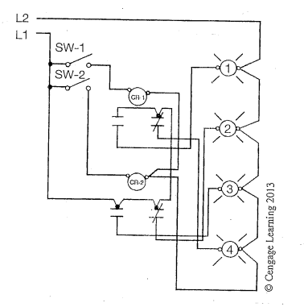

1. Convert the wiring diagram on page 137, question 12, into a ladder diagram.

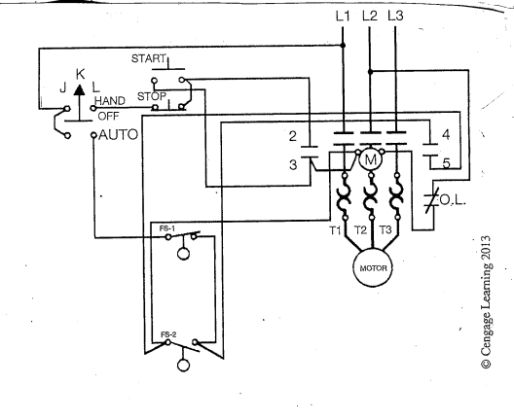

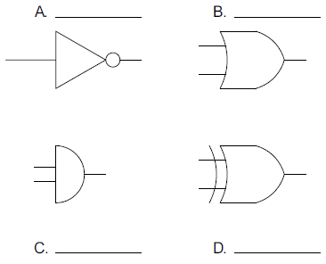

Identify the following logic gates: